**Create an Executable Spring Boot Standalone Application**

**Add a plugin in pom.xml**:

<plugin>

<groupId>org.springframework.boot</groupId>

<artifactId>spring-boot-maven-plugin</artifactId>

</plugin>

**Package up the application into a jar file**:

mvn clean package -DskipTests

**Use launch4j to create the executable file (.exe) with jre bundle**:

1. Create a new directory and copy jre folder into it.
2. Click launch4j.exe to open Launch4j GUI.
3. In Basic tab, specify output exe file location and the application jar file location. Icon for representing the exe application can also be specified.

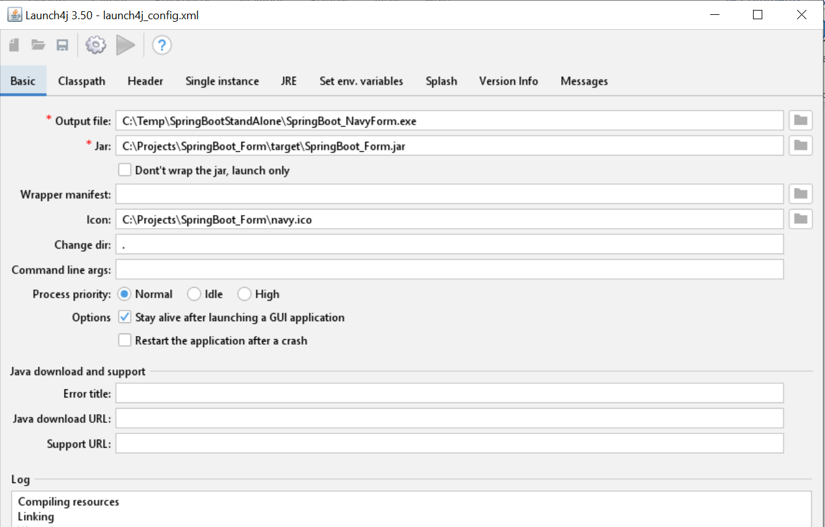

1. In Header tab, select Console option.

1. In JRE tab, specify jre directory in JRE paths.

1. Save the configuration as a .xml file and run it by clicking the gear icon. It should generate the standalone application with .exe file extension.

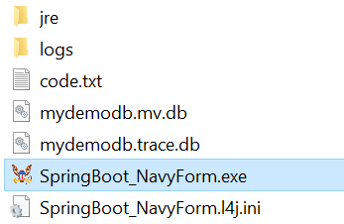

1. Click the .exe file, it should lunch the application console. The parent directory can be zipped up and deployed as a standalone application with jre bundle.

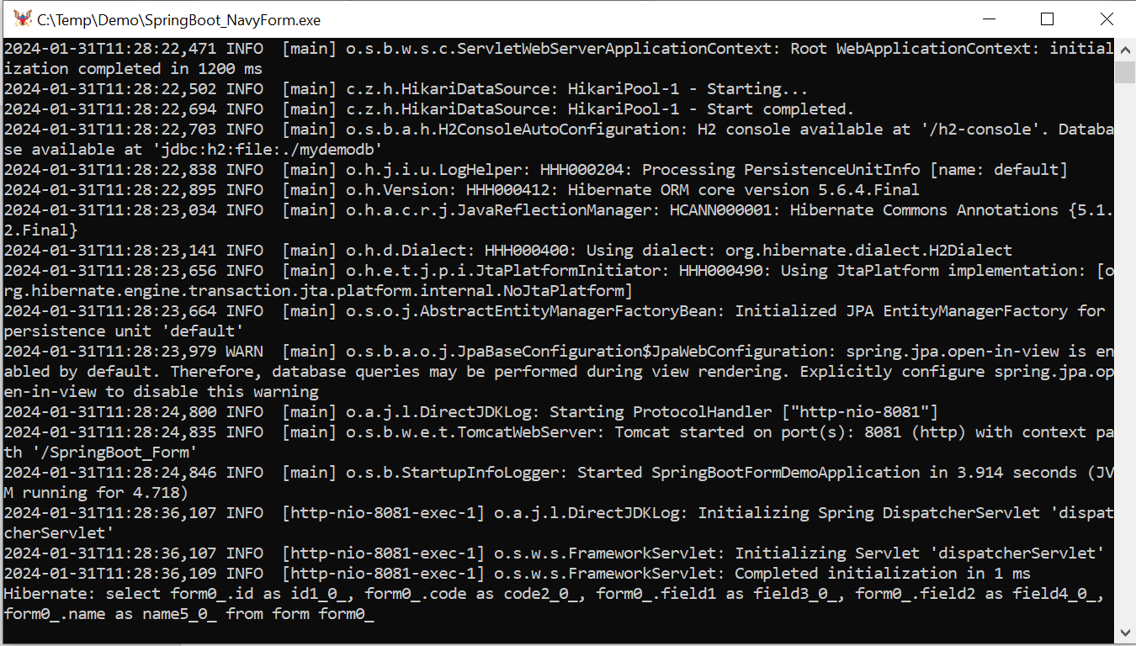

Can also use command line to run launch4j:

launch4j launch4j.xml

1. If run time arguments need to be specified, create a .l4j.ini file in the same directory where the .exe file resides. The l4j.ini file's name must correspond to the exe file (myapp.exe: myapp.l4j.ini). Example of contents in the .l4j.ini file:

-Dspring.config.location=classpath:/application.properties

-Dserver.port=8081

1. To access the portable database, use DBeaver as a universal SQL client. However, application needs to be terminated to unlock the database.
2. Alternatively, use http://localhost:8081/SpringBoot_Form/h2-console to access H2 console in browser:

Driver Class: org.h2.Driver

JDBC URL: jdbc:h2:file:./mydemodb

User Name: sa

Password: sa

Note: need to add spring.h2.console.enabled=true in application.properties

**References**:

Launch4j:

<https://launch4j.sourceforge.net/>

DBeaver:

<https://dbeaver.io/>